Earthquake Event Database and Visualization System
9-1 Final Project
CS-590-10407-M01 Database Design and Development
Ashanti Mia Terrell, MS, PMP, CSSBB
Southern New Hampshire University
​​Professor Zach Probst, M.S.​
​​June 21, 2026​

Modern organizations rely on large volumes of data to support decision-making, operational planning, and risk management. The United States Geological Survey (​USGS) continuously collects and publishes earthquake​ data ​from monitoring stations​ worldwide. This information provides valuable insights into seismic activity, including earthquake magnitude, location, depth, significance, and occurrence times. However, managing large datasets requires an efficient database solution capable of supporting storage, retrieval, ​analysis, and​ visualization.
The purpose ​of this project was to​ design, implement, and integrate a relational database solution for earthquake event data using PostgreSQL. RStudio was utilized to perform extraction, transformation, and loading (ETL) operations, while Shiny was used to develop an interactive dashboard for visualization and analysis. The completed solution demonstrates the full database development lifecycle, including data modeling, implementation, validation, security considerations, and application integration.

Problem Summary

The USGS earthquake dataset contains thousands of earthquake records generated from seismic monitoring systems around the world. Each earthquake event includes information regarding magnitude, location, depth, event timing, significance, tsunami indicators, and additional metadata.
The challenge presented by the dataset is the need to efficiently store, retrieve, and analyze large volumes of structured earthquake information. The project objective was to develop a relational database and integrated application that would allow users to visualize earthquake activity through multiple analytical perspectives while maintaining data integrity and performance.

Data Model Design

Database design is a critical component of information systems because it determines how efficient data can be stored, maintained, and retrieved. Effective schema design reduces redundancy, improves data quality, and supports scalability (Rabuzin et al., 2025).
The earthquake dataset was modeled using a relational database structure centered around a single entity called Earthquake_Event.
Entity Attributes
- event_id (Primary Key)
- magnitude
- place
- event_time
- updated_time
- ​​status​
- tsunami
- significance
- ​​magnitude_type​
- ​​event_type​
- longitude
- latitude
- depth_km

The event_id attribute serves as the primary key and uniquely identifies each earthquake event. Geographic coordinates and depth information were ​stored directly within the entity to​ simplify querying and dashboard development.

Entity Relationship Diagram

​​An Entity Relationship Diagram (ERD) was developed​ to visually represent the database structure.

Figure 1. Earthquake Event Entity Relationship Diagram
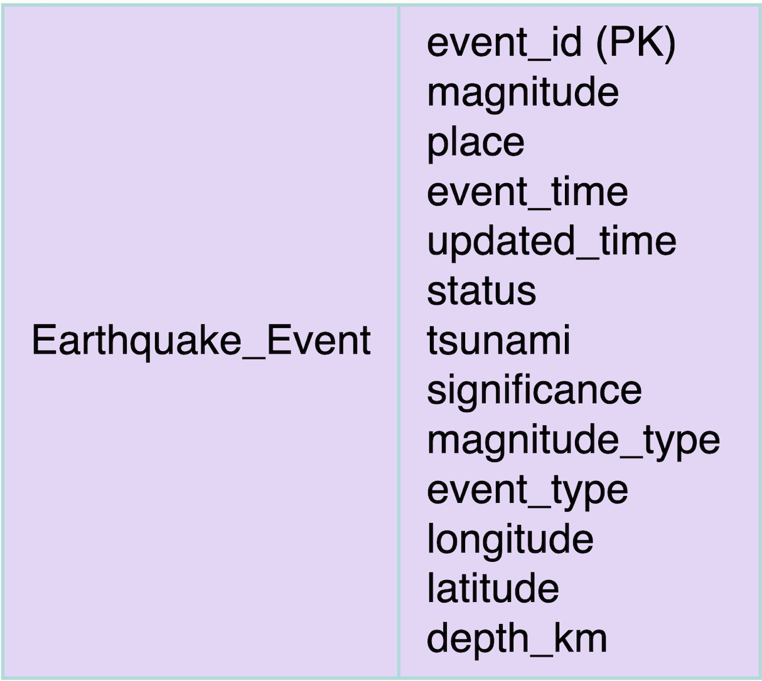
The ERD illustrates the Earthquake_Event entity and its attributes. The model provides a straightforward representation of the earthquake dataset while maintaining support for future expansion if additional entities become necessary.

​​Database Management System Selection​

PostgreSQL ​was selected as the database management system for this​ ​project because it provides​ a reliable, scalable, and open-source platform for managing structured data. PostgreSQL supports advanced indexing, strong data integrity controls, SQL compliance, and seamless integration with RStudio.
Alternative database technologies were considered. NoSQL systems such as MongoDB are often used for semi-structured data but were not necessary because the earthquake dataset contains consistent and highly structured attributes. Graph databases were also considered but were not appropriate because the dataset does not contain complex interconnected relationships requiring graph traversal.
PostgreSQL was determined to be the most appropriate solution because it efficiently supports relational storage, analytical querying, and integration with visualization tools.

Database Implementation

The database was implemented using PostgreSQL 18. A relational table named earthquake_events was created to store earthquake records imported from the USGS dataset.
The database schema included thirteen attributes aligned with the designed data model. The event_id field was established as the primary key to prevent duplicate records and maintain entity integrity.

To improve performance, indexes were created on magnitude and event_time.
Figure 2. PostgreSQL Database Table Creation

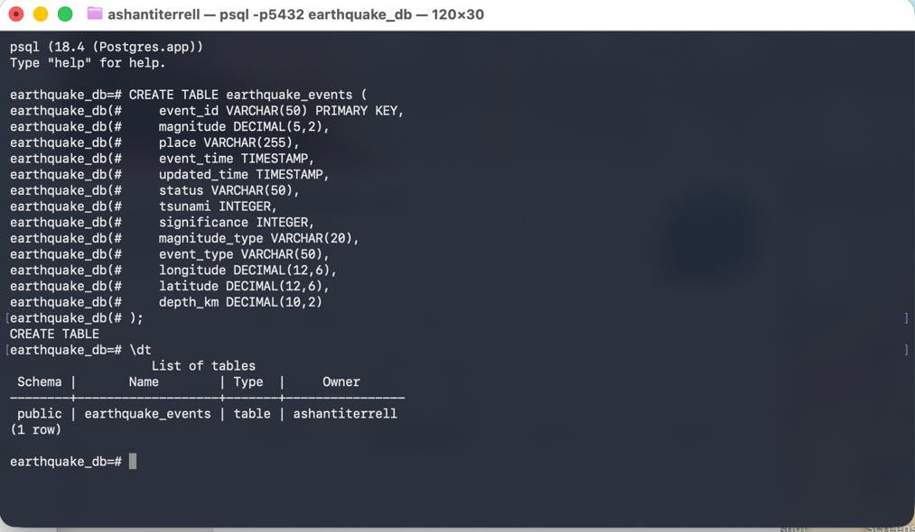

Data Transformation and ETL Process

The extraction, transformation, and loading (ETL) process was completed using RStudio. The earthquake dataset was provided in JSON format and required transformation before loading into PostgreSQL.
The ETL process consisted of the following steps:
- Extracting earthquake records from the JSON file.
- Parsing nested JSON structures using the jsonlite package.
- Converting Unix timestamps into PostgreSQL-compatible date and time formats.
- Extracting ​longitude, latitude, and depth values from​ coordinate arrays.
- Creating a structured data frame.
- Loading records into PostgreSQL using RPostgres.
​​A total of 6,701 earthquake records were successfully​ imported into the database.
Data preparation and transformation are essential components of effective data science workflows because they improve consistency and ensure analytical readiness (Timbers & Çetinkaya-Rundel, 2026).
Query Validation
Several SQL queries were executed to validate the database structure and verify successful data loading. The first query ​confirmed that​ all earthquake records were successfully loaded into the database.

SELECT COUNT(*)
FROM earthquake_events;
The query returned 6,701 records.
A second query identified the largest earthquakes in the dataset.
SELECT place,
magnitude,
event_time
FROM earthquake_events
WHERE magnitude >= 5
ORDER BY magnitude DESC
LIMIT 10;
This query successfully returned the highest-magnitude earthquake events and demonstrated that the database could support analytical reporting.

Figure 3. SQL Query Validation Results
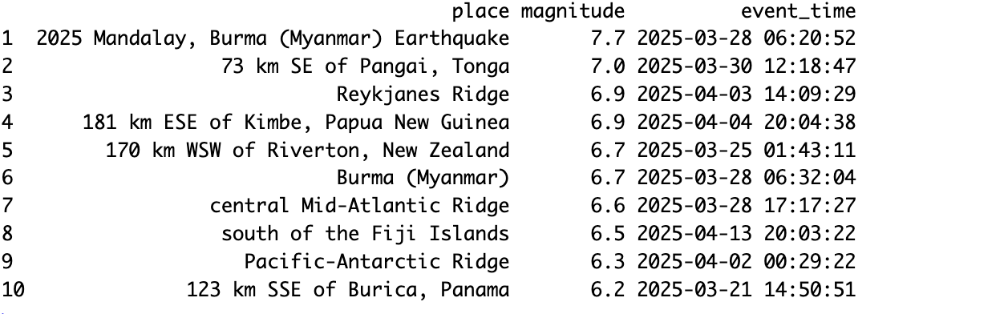
Database Design Techniques

Several database design principles were incorporated into the solution.
- Normalization
  - Normalization was applied to reduce redundancy and maintain consistency across records. Well-designed database structures improve maintainability and support efficient data retrieval (Rabuzin et al., 2025).
- Indexing
  - Indexes were created on magnitude and event_time to improve performance when filtering and sorting large datasets.
- Standardization
  - Date and time values were standardized during transformation to ensure consistency between RStudio and PostgreSQL.
- Data Transformation
  - The original JSON structure was transformed into a relational format suitable for PostgreSQL storage and SQL analysis.

Resource Requirements
​​The current​ database ​contains 6,701 earthquake records​. While storage requirements are small, future growth should be considered.
Future resource requirements include:
- Additional storage capacity
- Scheduled backups
- Increased memory allocation
- Support for real-time API integration
- Expanded dashboard usage
Regular backups should be implemented ​to protect against accidental data​ ​loss and system failures​.

Security Mechanisms
Several security controls were considered during implementation.
Authentication
PostgreSQL authentication restricts database access to authorized users.
Authorization
Role-based permissions can be implemented to control access to database objects and administrative functions.
Encryption
Encrypted communication channels such as SSL/TLS should be used when transmitting data between applications and databases. These controls support confidentiality, integrity, and availability of database resources.

Database and Application Integration
The PostgreSQL database was integrated with an application developed in RStudio using the Shiny framework.
The application provides users with:
- Project Information
- Magnitude Distribution Analysis
- Earthquake Location Mapping
- Summary Statistics
The dashboard demonstrates successful integration between the database and application environment.
Data Visualization
​​Data visualization is a critical component of modern analytics because it​ ​transforms complex datasets into meaningful insights​. Effective visualizations improve interpretation and support decision-making (Choudhary et al., 2024).
Magnitude Distribution Histogram
The histogram displays the distribution of earthquake magnitudes and illustrates that most earthquake events occur within lower magnitude ranges.
Figure 4. Earthquake Magnitude Distribution
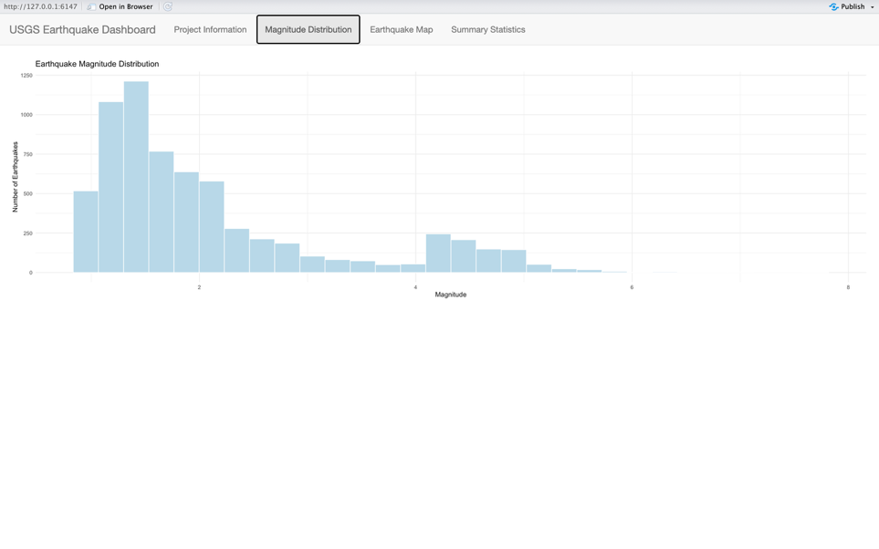
Global Earthquake Location Map
The interactive Leaflet map visualizes earthquake locations worldwide using geographic coordinates.
Figure 5. Global Earthquake Location Map
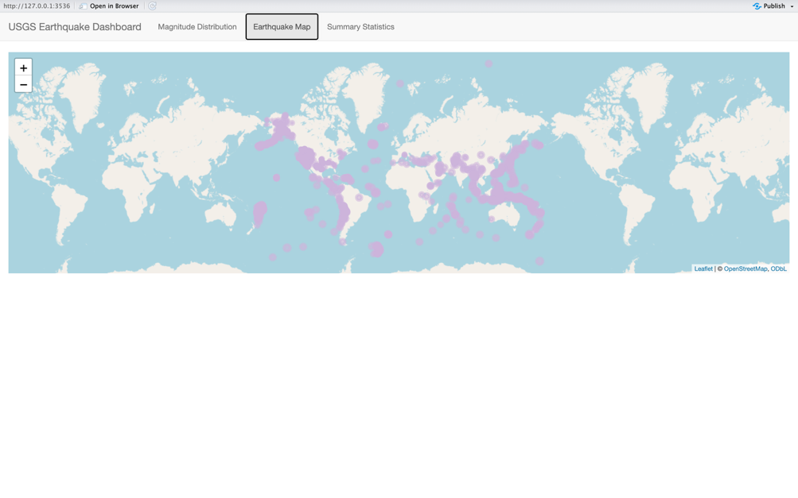
Interactive Dashboard
The Shiny dashboard integrates multiple visualizations into a single application environment. Dashboards enhance analytical capabilities by providing users with multiple perspectives of the data within a centralized interface (Choudhary et al., 2024).

Figure 6. Earthquake Dashboard
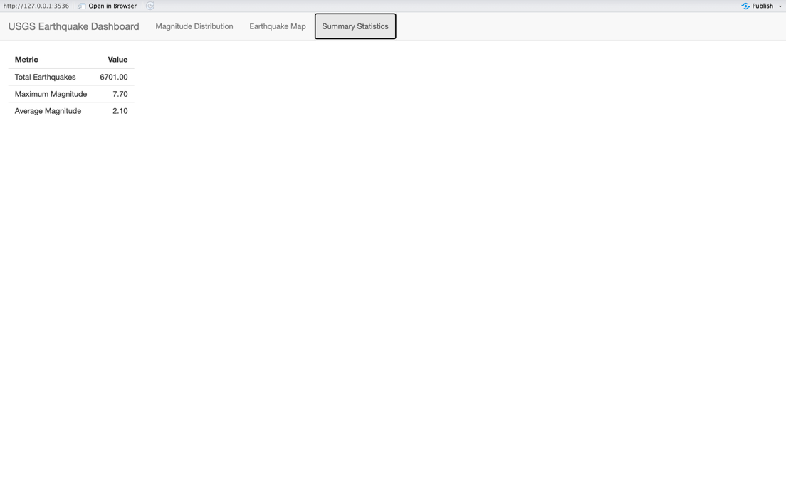
Conclusion
This project successfully demonstrated the design, implementation, and integration of a relational database solution using PostgreSQL, RStudio, and Shiny. The completed system stores 6,701 earthquake records and provides analytical capabilities through SQL querying, visualization, and dashboard reporting.
The project highlights the importance of effective database design, data transformation, and visualization in supporting data-driven decision-making. Future enhancements may include automated API integration, predictive modeling, and advanced geospatial analytics.

References
Choudhary, V. K., Kumar, G., Suman, S., & Kumar, A. (2024). A Comprehensive Review on Data Visualization Techniques for Real-Time Information. 2024 International Conference on Inventive Computation Technologies (ICICT), Inventive Computation Technologies (ICICT), 2024 International Conference On, 866–871. https://doi.org/10.1109/ICICT60155.2024.10544996
Timbers, T. A., & Çetinkaya-Rundel, M. (2026). Ten simple rules for teaching data science. PLoS Computational Biology, 22(6), 1–11. https://doi.org/10.1371/journal.pcbi.1014338
Rabuzin, K., Cerjan, M., & Lovrenčić, A. (2025). Data Warehouse Design -- Star Schema Synthesis Algorithm. TEM Journal, 14(2), 1707–1714. https://doi.org/10.18421/TEM142-68

